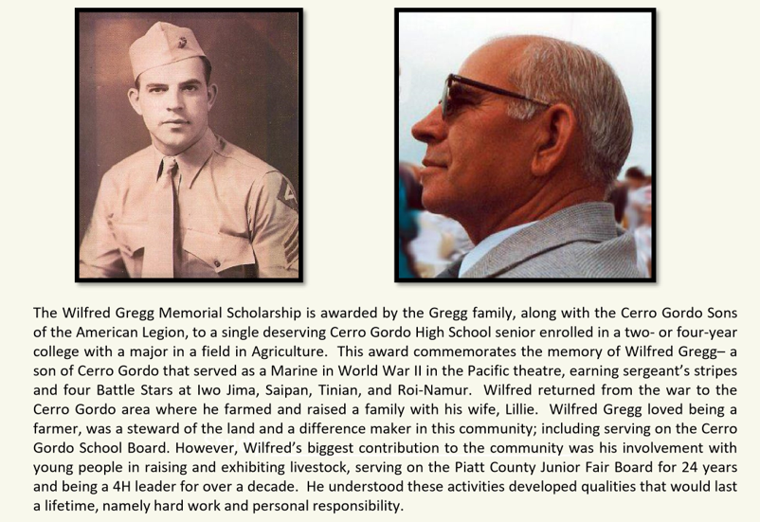
Award Amount: $1,000.00
Criteria
- Student will be admitted into a two- or four-year college in the field of Agriculture.
- Student should carry a C average or better at Cerro Gordo High School.
- Student will present a short essay (250-500 words) with the theme of “How do you plan to use your degree in Agriculture?”. The student can also include other additional information in the essay that might be helpful to the Selection Committee.
- Student is a member of the Future Farmers of America or participated in 4-H. Special consideration for a student that raised livestock.
- Provide one letter of recommendation.
Selection Committee
- The Selection Committee for the Wilfred Gregg Memorial Scholarship is Jerry Gregg, Kevin Gregg and Darin Gregg.
Application Deadline and Award Notification
- Application deadline is April 12, 2024.
- Winning applicant will be notified prior to the Cerro Gordo High School Honors Night ceremony.
- The $1,000.00 scholarship will be awarded upon the selected applicant’s completion of their first semester of college with a minimum of 12 accredited hours and a GPA of 2.0 or above.
Applicant’s Name________________________________________________________
Applicant’s Email Address________________________________________________
Parent’s Name___________________________________________________________

What colleges have you applied to and been accepted by?
College___________________________________ Field of Study_________________________________
College___________________________________ Field of Study_________________________________
College___________________________________ Field of Study_________________________________

Cumulative High School GPA:____________/4.0

I, ___________________________________ attest that all information on this application is correct and truthful. I understand that the committee will verify the information submitted in this application.
______________________________________________ ____________________________
Applicant’s Signature Date

Application Submission Instructions:
The completed application page, letter of recommendation and essay should be emailed to Darin Gregg at darinrgregg@gmail.com and Mr. Willard at bwillard@cgbroncos.org with “Name and 2024 Gregg Scholarship Application” in the subject line, before April 12, 2024.

