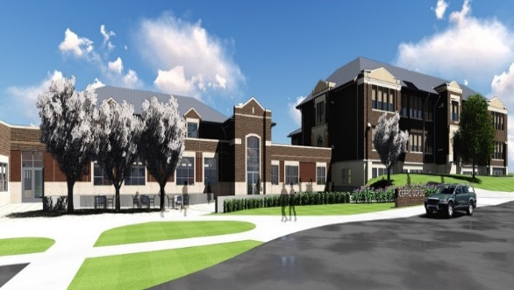
Average class size:
14

Period Scheduling
Classes are scheduled on a straight 8 period day, with each class being 42 minutes in length.

Graduation Requirements
Students are required to have 26 credits to graduate plus 25 community service hours (beginning with the class of 2025).

Course Requirements for graduation
4 credits of English
3 credits of Math
3 credits of Science
3 credits of Social Science
1 semester of Resource Management
1 semester of Health
1 semester of Driver’s Ed
PE is required yearly
Electives: Foreign Language (Spanish and French), Art, Music/Chorus, Publications, Agriculture, Business, Industrial Technology and Family and Consumer Sciences
Accredited by the Illinois State Board of Education, Cerro Gordo CUSD #100 consists of an elementary school and a junior/senior high school totaling 460 students. Cerro Gordo High School enrolls 119 students while 100 students are in the junior high school. CGHS is in the Richland Community College district.

Community: The Village of Cerro Gordo, county of Piatt, population 1300, is located in central Illinois, conveniently situated between Decatur (12 miles) and Champaign-Urbana (35 miles). The median income for a household in the village is $40,529, and the median income for a family is $45,250. Agriculture and manufacturing are the primary industries.

MISSION STATEMENT
Successful learning experiences will be provided for every student each day. The staff at Cerro Gordo High School is committed to teaching for learning for all students. Teaching for learning includes continued learning for educators as well as students. Our vision is to develop curricula and lessons with the “end in mind.” Thus creating an efficient and effective “results oriented” school that successfully serves all students.

Cerro Gordo High School
Profile and Transcript Data
Home of the Broncos!

Cerro Gordo, IL

Cerro Gordo CUSD #100
300 E. Durfee St.
PO Box 79
Cerro Gordo, Il 61818
Phone: (217) 763-2711
Fax: (217) 763-6287
CEEB Code: 140585
www.cgbroncos.org

Class stats:
Freshman class: 33
Sophomore class: 26
Junior class: 36
Senior class: 24
Teachers: 18

CEEB Code:
140585

Superintendent-Dr. Emily Weidner Principal-Mr. Brandon Willard
Athletic Director-Mrs. Diann Durbin School Counselor-Mrs. Renee Probst

Course Offerings
Grading System

A= 90-100 B= 80-89 C= 70-79
D= 60-69 F= 59 and below
**Grades are not weighted**

2023-2024

English
Composition/Literature 1
Composition/Literature 2
Composition/Literature 3
Composition/Literature 4 OR DC ENG 101 and 102

Math
Algebra I
Geometry
Algebra 2
Trig/Pre-Calc
Calculus

Science
Biology
Physical Science
Earth Science
Chemistry
Physics

PE/Health/Driver’s Ed.
PE
Health
Dual credit courses are available through Richland Community College’s Transfer Academy and Heartland Technical Academy.
Dr. Ed.

History
World History
American History
Government
Geography
Sociology
Psychology

Foreign Language
Spanish 1, 2, 3, 4
French 1, 2, 3, 4

Art
Art 1, 2, 3, 4

Publications
Yearbook

Music
Band
Chorus
General Music
Music Theory

Agriculture
Intro. To Ag
Ag Science
Ag Mechanics
Horticulture
Animal Care
Vet Science

Business
Computer Applications

Industrial Technology
Intro. Industrial Tech

Family and Consumer Science
Early Childhood Education
Orientation to FCS
Foods and Nutrition
Parenting Adult Living

Work Program

